SIMATS ENGINEERING
ASSESSMENT TOOL 2

COURSE CODE: ITA 0604 COURSE NAME: MACHINE LEARNING

CONCEPT MAPPING

1.With the necessary sketch, explain all the possible blocks in the machine-learning system. Give example for showing the concept of the supervised and Un-supervised learning methods in the machine learning scheme.

Introduction
Machine Learning (ML) is a branch of Artificial Intelligence (AI) that enables computers to learn from data and make predictions without being explicitly programmed.

Blocks of a Machine Learning System
- Data Collection: Collect data from databases, sensors, or files.
- Data Preprocessing: Clean the data by removing missing values and duplicates.
- Feature Selection/Extraction: Select important features for training.
- Machine Learning Algorithm: Choose a suitable algorithm such as Decision Tree, Naïve Bayes, or K-Means.
- Model Training: Train the model using the prepared data.
- Model Testing & Evaluation: Test the model and evaluate its performance using metrics like accuracy and precision.
- Prediction/Output: Use the trained model to predict results for new data.

Machine Learning System Sketch
Input Data
│
▼
Data Collection
│
▼
Data Preprocessing
│
▼
Feature Selection
│
▼
ML Algorithm
│
▼
Model Training
│
▼
Testing & Evaluation
│
▼
Prediction / Output

1. Supervised Learning
- Uses labeled data (input and output are known).
- The model learns from examples and predicts outputs.
Example:
Student Marks | Result
90 | Pass
35 | Fail
75 | Pass
Applications:
- Email spam detection
- Disease prediction
- House price prediction

2. Unsupervised Learning
- Uses unlabeled data (output is not known).
- The model finds hidden patterns or groups.
Example:
Customer data is grouped into:
- Frequent buyers
- Regular buyers
- New customers
Applications:
- Customer segmentation
- Market analysis
- Recommendation systems

Difference Between Supervised and Unsupervised Learning
Supervised Learning | Unsupervised Learning
Uses labeled data | Uses unlabeled data
Predicts output | Finds hidden patterns
Example: Spam detection | Example: Customer segmentation

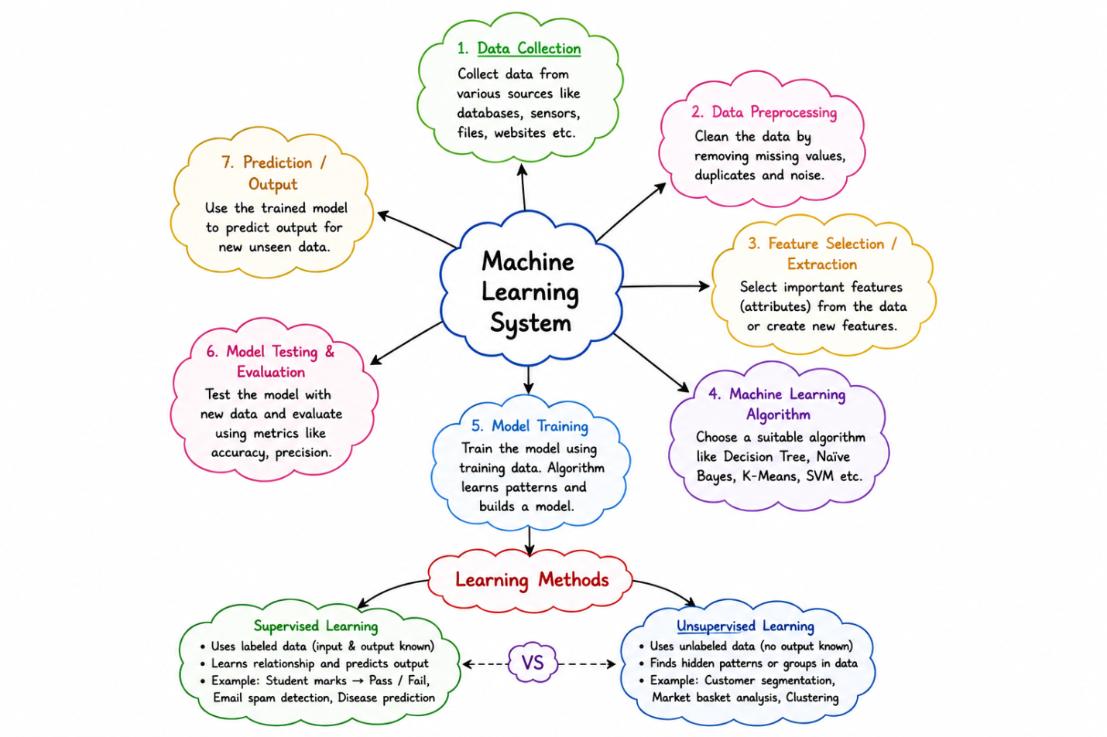Conclusion
A machine learning system consists of data collection, preprocessing, feature selection, algorithm selection, model training, testing, and prediction. Supervised learning predicts outputs using labeled data, whereas unsupervised learning discovers hidden patterns from unlabeled data. These methods are widely used in healthcare, finance, manufacturing, and business applications.

2. Design a machine learning system for disaster management to predict events such as floods and earthquakes using historical and real-time data. Explain the choice of model, data preprocessing, and feature selection techniques.
(a) Describe the steps involved in training, validating, and evaluating the model.
(b) Explain how the system can assist in early warning and emergency response.

Introduction
A Machine Learning (ML) system for disaster management predicts natural disasters such as floods and earthquakes using historical and real-time data. It provides early warnings to reduce loss of life and property.

Machine Learning System Design

1. Data Collection
Collect data from:
- Historical disaster records
- Rainfall and weather stations
- River water levels
- Seismic sensors
- Satellite images

2. Data Preprocessing
Data is cleaned by:
- Removing missing values
- Removing duplicate records
- Normalizing data
- Converting data into a standard format

3. Feature Selection
Important features include:
- Rainfall
- River water level
- Temperature
- Humidity

4. Choice of Model
Suitable machine learning models:
- Random Forest – High accuracy for flood prediction.
- Decision Tree – Easy to classify disaster levels and interpret results.

5. Prediction
The trained model predicts:
- Flood risk
- Earthquake probability
- Disaster warning level

Workflow
Historical & Real-Time Data
│
▼
Data Preprocessing
│
▼
Feature Selection
│
▼
Machine Learning Model
(Random Forest/Decision Tree)
│
▼
Model Training & Validation
│
▼
Disaster Prediction
│
▼
Early Warning & Response

(a) Steps Involved in Training, Validating, and Evaluating the Model

Step 1: Training
- Divide the collected data into training and testing datasets.
- Train the model using historical disaster data.
- The model learns patterns related to floods and earthquakes.

Step 2: Validation
- Validate the model using validation data.
- Adjust model parameters to improve prediction accuracy.
- Prevent overfitting and improve performance.

Step 3: Evaluation
Evaluate the trained model using performance metrics such as:
- Accuracy
- Precision
- Recall (Sensitivity)
- F1-Score
If the accuracy is satisfactory, the model is deployed for real-time prediction.

(b) Early Warning and Emergency Response
The machine learning system assists disaster management by:
- Predicting floods and earthquakes before they occur.
- Sending early warning alerts to the public and authorities.
- Helping emergency teams prepare rescue operations.
- Supporting evacuation planning for affected areas.
- Reducing loss of life and property.
- Assisting government agencies in disaster response and resource allocation.

Applications
- Flood forecasting
- Earthquake prediction
- Disaster monitoring
- Emergency response planning
- Risk assessment

Conclusion
A machine learning system combines historical and real-time data to predict natural disasters accurately. Using Random Forest and Decision Tree models, along with proper data preprocessing and feature selection, the system provides reliable disaster predictions. It supports early warning systems, improves emergency response, and helps protect people and infrastructure from natural disasters.

12. Design a machine learning model for spam email classification using labeled data. (5 Marks)

(a) Explain the choice of algorithm (e.g., Naïve Bayes, SVM, or Logistic Regression).

(b) Describe the preprocessing steps such as tokenization, stop-word removal, and vectorization.

(c) Discuss evaluation metrics such as accuracy, precision, recall, and F1-score.12. Machine Learning Model for Spam Email Classification.

Introduction
A Spam Email Classification System uses Machine Learning to classify emails as Spam or Not Spam (Ham) using labeled data. The model learns from previously labeled emails and predicts whether a new email is spam.

Machine Learning Model

Workflow
Labeled Email Data
│
▼
Data Preprocessing
│
▼
Feature Extraction
(Vectorization)
│
▼
Machine Learning Model
(Naïve Bayes)
│
▼
Model Training
│
▼
Spam / Not Spam Prediction

(a) Choice of Algorithm

Naïve Bayes Algorithm
Naïve Bayes is commonly used for spam email classification because:
- Works well with text data.
- Fast and simple to implement.
- Handles large email datasets efficiently.
- Provides high accuracy for spam detection.
Example:
- Spam: "Congratulations! You won a prize."
- Not Spam: "Meeting scheduled at 10 AM."
The model learns these patterns and classifies future emails.

(b) Data Preprocessing Steps

1. Tokenization
Split the email into individual words.
Example:
"Win a free gift"
↓
Win | a | free | gift

2. Stop-word Removal
Remove common words that do not add meaning.
Remove words like:
- is
- the
- a
- an
- and
Result:
Win | free | gift

3. Vectorization
Convert text into numerical values using techniques such as:
- Count Vectorizer
- TF-IDF (Term Frequency–Inverse Document Frequency)
These numerical vectors are used to train the model.

(c) Evaluation Metrics
The performance of the spam classifier is measured using:
- Accuracy: Percentage of correctly classified emails.
- Precision: Percentage of predicted spam emails that are actually spam.
- Recall (Sensitivity): Percentage of actual spam emails correctly detected.
- F1-Score: Harmonic mean of Precision and Recall.
Higher values indicate better model performance.

Applications

Email spam filtering
- Phishing email detection
- Cybersecurity systems
- Business email security
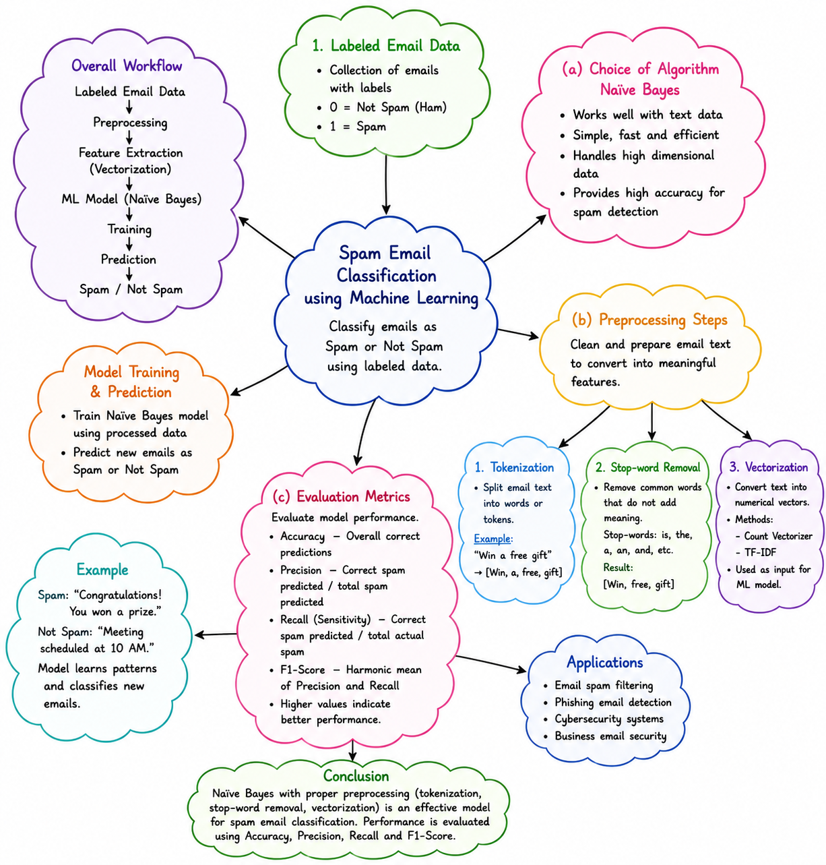

Conclusion
A Naïve Bayes classifier is an effective model for spam email detection because it is simple, fast, and accurate. After tokenization, stop-word removal, and vectorization, the model is trained using labeled emails. Performance is evaluated using Accuracy, Precision, Recall, and F1-Score, making the system reliable for identifying spam and protecting users from unwanted emails.

